Snails

2022-08-15

snails <- read.csv("~/Desktop/Advances in Marine Biology/All Snail Data.csv")  
  
summary(snails)

## Site Zone Zone_Site Transect   
## Length:1500 Length:1500 Length:1500 Length:1500   
## Class :character Class :character Class :character Class :character   
## Mode :character Mode :character Mode :character Mode :character   
##   
##   
##   
##   
## Quadrat ID Species Position   
## Length:1500 Min. : 1.0 Length:1500 Length:1500   
## Class :character 1st Qu.: 375.8 Class :character Class :character   
## Mode :character Median : 750.5 Mode :character Mode :character   
## Mean : 750.5   
## 3rd Qu.:1125.2   
## Max. :1500.0   
##   
## Size   
## Min. : 1.000   
## 1st Qu.: 3.000   
## Median : 8.000   
## Mean : 9.558   
## 3rd Qu.:15.000   
## Max. :47.000   
## NA's :14

# Abundance by location

snails_new <- snails  
  
snails_new$Zone <- factor(snails_new$Zone, c("Low", "Mid", "High"))  
counts <- table(snails_new$Site, snails_new$Zone)  
counts

##   
## Low Mid High  
## North 60 1118 53  
## South 142 102 25

barplot(counts, beside=TRUE, xlab = "Intertidal zone", ylab = "Abundance", legend = c("North","South"), col=c("brown2", "cornflowerblue"), main = "Total abundance by intertidal zone")

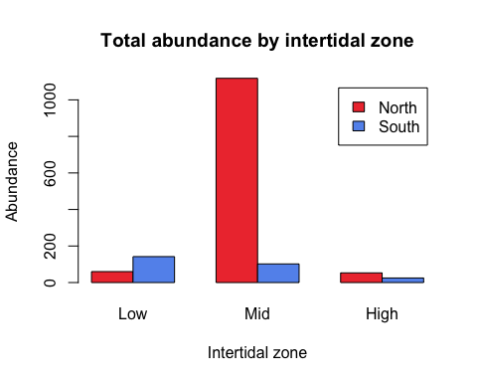

# Size frequency distribution

library(lattice)  
bwplot(snails$Size ~ snails$Site, xlab = "Site", ylab = "Size (mm)", main = "Gastropod size by site")

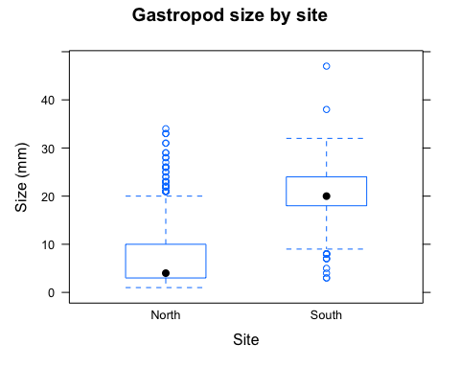

snails_new$Zone <- factor(snails_new$Zone, c("Low", "Mid", "High"))  
bwplot(snails_new$Size ~ snails_new$Zone, xlab = "Intertidal zone", ylab = "Size (mm)", main = "Gastropod size by intertidal zone")

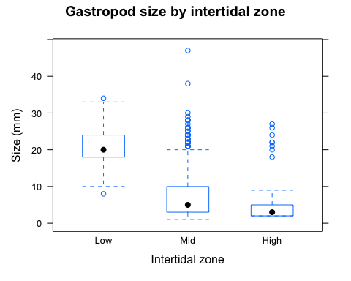

snails_new <- snails  
snails_new$Zone_Site <- factor(snails_new$Zone_Site, c("Low North", "Low South", "Mid North", "Mid South", "High North", "High South"))  
bwplot(snails_new$Size ~ snails_new$Zone_Site, xlab = "Site", ylab = "Size (mm)", main = "Gastropod size by site")

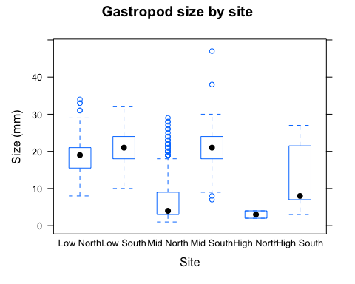

# Testing for normality  
hist(snails_new$Size)

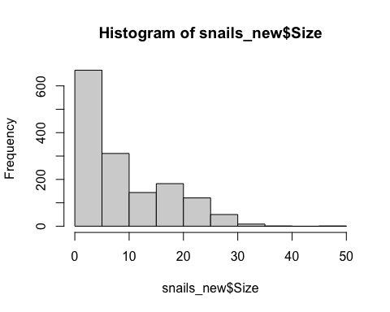

# QQ Plot  
qqnorm(snails_new$Size)  
qqline(snails_new$Size)

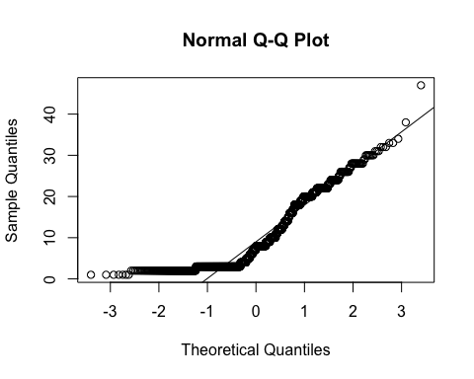

# Shapiro-Wilk test  
shapiro.test(snails_new$Size)

##   
## Shapiro-Wilk normality test  
##   
## data: snails_new$Size  
## W = 0.85399, p-value < 2.2e-16

# Conclusion: NOT NORMAL  
  
  
# Mann-Whitney U Test for Size by Site (N/S)  
wilcox.test(Size ~ Site, data = snails_new)

##   
## Wilcoxon rank sum test with continuity correction  
##   
## data: Size by Site  
## W = 25162, p-value < 2.2e-16  
## alternative hypothesis: true location shift is not equal to 0

# p < 0.05 --> reject the null that there is no difference in size between the two sites (N/S)  
# Sufficient evidence to conclude that there is a significant difference in size between the two sites (N/S)  
  
  
# Kruskal-Wallis Test for Size by Zones (Low/Mid/High)  
kruskal.test(Size ~ Zone, data = snails_new)

##   
## Kruskal-Wallis rank sum test  
##   
## data: Size by Zone  
## Kruskal-Wallis chi-squared = 371.01, df = 2, p-value < 2.2e-16

# p < 0.05 --> reject the null hypothesis that there is no difference in size across zones  
# Sufficient evidence to conclude that there is a significant difference in size across the intertidal zones

# Species abundance

snails_new$Zone <- factor(snails_new$Zone, c("Low", "Mid", "High"))  
  
library(tidyverse)

## ── Attaching packages ─────────────────────────────────────── tidyverse 1.3.2 ──  
## ✔ ggplot2 3.3.6 ✔ purrr 0.3.4  
## ✔ tibble 3.1.8 ✔ dplyr 1.0.9  
## ✔ tidyr 1.2.0 ✔ stringr 1.4.0  
## ✔ readr 2.1.2 ✔ forcats 0.5.1  
## ── Conflicts ────────────────────────────────────────── tidyverse_conflicts() ──  
## ✖ dplyr::filter() masks stats::filter()  
## ✖ dplyr::lag() masks stats::lag()

snails_new %>%   
 filter(!is.na(Species)) %>%   
 ggplot() +  
 geom_bar(mapping = aes(fill = Species, x = Zone), na.rm = T) +  
 ggtitle("Gastropod species distribution across intertidal zones")

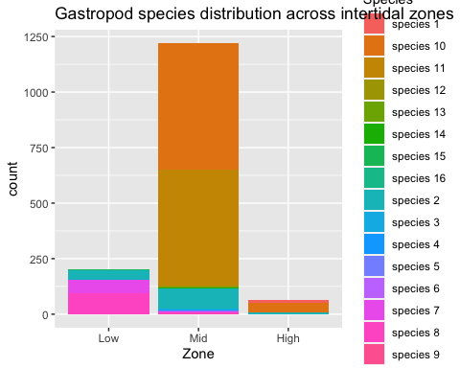

# use percentages instead!  
library(tidyverse)  
  
snails_new %>%   
 filter(!is.na(Species)) %>%   
 ggplot() +  
 geom_bar(mapping = aes(fill = Species, x = Zone), color = "black", position = "fill", na.rm = T) +  
 ggtitle("Gastropod species distribution across intertidal zones")+  
 scale_fill_discrete(breaks=c('species 1', 'species 2', 'species 3', 'species 4', 'species 5', 'species 6', 'species 7', 'species 8', 'species 9', 'species 10', 'species 11', 'species 12', 'species 13', 'species 14', 'species 15', 'species 16')) +  
 ylab('Proportion of total count')

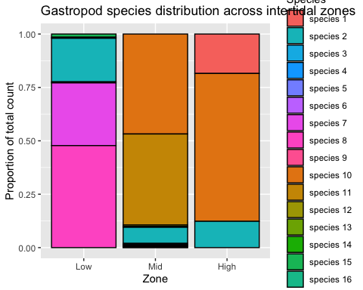

# species richness by zone - frequency analysis  
  
# multivariate analysis?